Setting Up PySpark in Local Mode (No Full Spark Installation Required)
This guide will help you install and run PySpark on your local machine in "local mode." This setup is perfect for learning and development without needing a full Apache Spark installation.

Step 1: Install PySpark
- Open Command Prompt:
  - Type the following command to install PySpark via pip:
pip install pyspark

Step 2: Install Java
- Download and Install Java:
  - PySpark requires Java. Download the Java Development Kit (JDK) and install it.
- Set JAVA_HOME:
  - Go to System Properties > Advanced > Environment Variables.
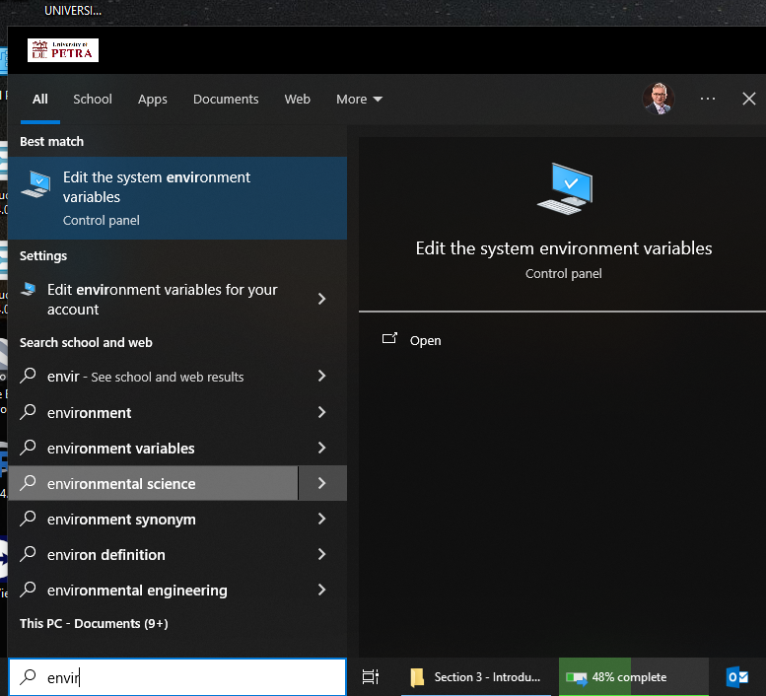
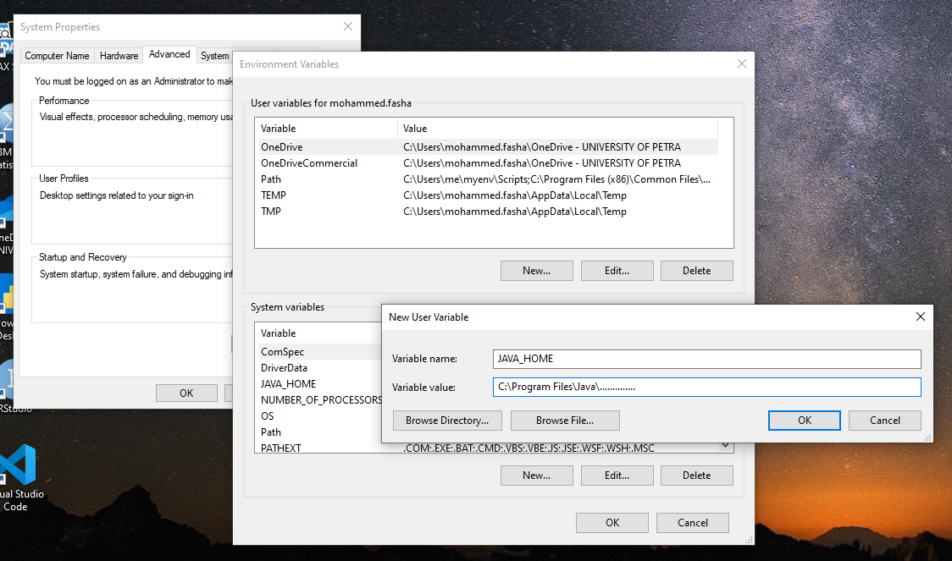
  - Create a new variable called JAVA_HOME and set it to your JDK installation path, e.g., C:\Program Files\Java\jdk-x….
  - Add %JAVA_HOME%\bin to the PATH variable in Environment Variables.

Step 3: Test PySpark
- Open a Python Environment:
  - You can use any Python IDE, command prompt, or Jupyter Notebook.
- Run Sample Code:
  - Copy and run the following code to test PySpark:
from pyspark.sql import SparkSession

# Create a Spark session
spark = SparkSession.builder.master("local").appName("local_test").getOrCreate()

# Create a sample DataFrame
data = [("Alice", 1), ("Bob", 2), ("Charlie", 3)]
columns = ["Name", "ID"]
df = spark.createDataFrame(data, columns)

# Show the DataFrame
df.show()

# Stop the Spark session
spark.stop()
  - If everything is set up correctly, the DataFrame will display a table with Name and ID columns.

